**Leader Overview**

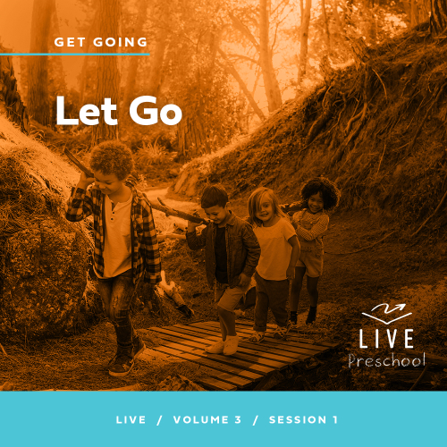

**Volume Overview**

**Get Going**

*The gift of the Holy Spirit was sent so that we might have power—power to go and make disciples. Some go to the farthest corners of the globe. Some only cross the street in front of their house. Still, God’s people always go. They go to work, school, grocery stores, kids’ soccer games, and family reunions. And wherever they go, they take their witness of Jesus with them. True believers live going and carrying out His mission.*

**Session Overview**

**Let Go**

*In this* **Live** *session, preschoolers will explore the story of Peter leaving things behind to follow Jesus. They’ll discover that even when Jesus tells us to do something unexpected, we can make a big difference when we say yes to Him.*

**Bible Lesson**

The First Disciples Leave Everything

[Luke 5:1–11](https://ref.ly/logosref/Bible.Lk5.1-11)

**Faith Fact**

I can make a difference.

**Faith Verse**

[John 20:21](https://ref.ly/logosref/Bible.Jn20.21) (NLT)

[Jesus] said, ”Peace be with you. As the Father has sent me, so I am sending you.”

**Preparing for the Session**

**Leader Preparation Time: 20–25 Minutes**

|  |
| --- |
| ***You Will Need***  ***Preservice Activities***  *• Toy boat*  *• Goldfish crackers*  *• Toys*  ***Large Group***  *• Bible*  *• Worship songs (Song suggestions: “Do What You Wanna Do” Lyric Video by Elevation Church Kids; “I Know I Belong” Lyric Video by Saddleback Kids*  *• For groups not using a phone or tablet only, add:*  *• Projector or TV*  *• Laptop*  *•* ***Faith Fact Sound*** *video (bell ringing)*  *•* ***Faith Fact Slide***  *•* ***Faith Verse Slide*** *or* ***Video***  *•* ***Bible Lesson Video A***  *•* ***Bible Lesson Video B***  ***Small Group***  *• Dominoes or Jenga® blocks*  *• Table or flat surface*  *•* ***Small Group Activity Page****, one per kid*  *• Crayons or markers*  *• Small balls (table tennis balls, cotton balls, or wadded up paper balls), ten to twelve*  *• Bucket or container*  *• Round disposable tablecloth, blue if available*  *•* ***Small Group Hands-On Learning Page****, one per two kids*  *• Assorted mail (letters, large envelopes, boxes, etc.)*  *• Crayons or markers*  *• Scissors*  *• Card stock, if available*  *• Optional: World map if you have a place to display the kids’ postcards*  To access session content and videos from a computer, visit: [**BibleEngagementProject.com/downloads**](https://bibleengagementproject.com/downloads) |
| ***Getting Ready***  ***Preservice Activities***  *• Set out toys and snacks.*  ***Large Group***  *• Download videos and slides if needed.*  *• Select worship song(s) and have them ready to play.*  ***Small Group***  *• Print copies of the* ***Small Group Activity Page****, one per kid.*  *• Place the tablecloth on the floor with the bucket in the middle of the tablecloth.*  *• Print the* ***Small Group Hands-On Learning Page*** *on card stock (if available) and cut apart, one per two kids.*  *• Optional: Write the Faith Verse on the world map.*  ***First time leading* Live *for Preschool? Check out the*** [**Facilitator Guide**](https://0b769b0ed3569ef9d18b-f88d8272f61086866d50d048b43ef630.ssl.cf2.rackcdn.com/sites/biblengagementproject/Listen_Facilitator_Guide.pdf)**.** |

**Preservice Activities**

*See what’s needed at the beginning of the session.*

**Bible Story Warm-Up**

How many of you like to play in the water? *(Group response)* What are some things you can do in the water? *(Allow responses.)*

Those were really great answers. One of the things that can go in the water is a boat. *(Hold up the toy boat.)* Now this boat isn’t big enough for you to ride on, but it’s definitely big enough for you to play with in the water.

Where would you see a boat?

Have you ever been on a boat? What were you doing?

What are some other kinds of things you might find in water?

In the Bible, Jesus spent time on boats. In fact, He had a few friends who worked on boats because they were fishermen. What do fishermen catch? *(Group response)* What do you think there will be lots of in our Bible story? *(Allow responses.)* Fish! We’ll find out how Jesus used fish to help Peter follow Him. Jesus wants to use people like you and me to make a big difference in the world around us. I can’t wait to learn more from the Bible with you today.

**Snack**

**Goldfish Crackers**

Today, we have a yummy snack for you. Don’t eat it when you get it. I want you to take a few seconds and count your fish first. When you’re finished counting them, raise your hand and tell me how many you have.

• *Hand out the goldfish crackers.*

• *Allow kids time to count their snack. After they finish counting and announce the number of crackers they have, allow them to eat their snack.*

Great job counting your fish! Have you ever caught a fish? *(Allow responses.)* How many fish did you catch? *(Allow responses.)* In today’s Bible story, we’ll learn about a time that Jesus’ friends caught more fish than they could pick up. I don’t know about you, but I’m glad we only had a few fish to count in our snack today.

**Free Play**

*Any extra time can be spent playing with toys.*

**Transition**

*A few minutes before service begins have kids make their way to the large group area and sit in their designated areas.*

**Large Group**

**25 Minutes**

*See what’s needed at the beginning of the session.*

**Introduction**

I’m so excited that you’re here today! We’ll have so much fun learning from God’s Word together. *(Hold up the Bible.)* If you’re excited to be here, raise your hand! *(Group response)*

Great! Today, we’ll learn about a time when a man named Peter had fished all night long and hadn’t caught any fish. Then, Jesus told him to go out one more time, and he obeyed Jesus. Peter caught so many fish that his boat could barely hold them.

**Faith Fact**

Then Jesus told Peter to come follow Him. Instead of catching fish, Peter would have the chance to make a big difference in people’s lives. That’s our Faith Fact: **I can make a difference.**

• *Show the* ***Faith Fact Slide.***

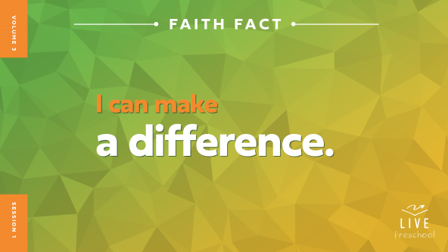

Let’s say our Faith Fact together. **I can make a difference.** Awesome! Did you know that when you help someone, it makes a difference in their life? This time hold your arms out like you’re helping someone. **I can make a difference.** Now, let’s shout it! **I can make a difference.**

**Bible Time**

One of the most important things we do together is learn from God’s Word, the Bible. We’ve got a special friend to help us do that. Let’s see what Lizzy is doing.

• *Play* ***Bible Lesson Video A.***

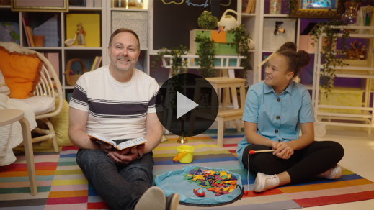

I’m glad Grandpa gave us a little time to think! Let’s take some time to worship God. Then, I’ll ask you what you think is going to happen next in our Bible story.

**Worship**

One way we can show God how much we love Him is with praise and worship. When we praise God, we think about how good and loving He is. We use our voices to show God our love.

**Praise**

Who wants to thank Jesus for calling us to be on His team? Pretend you’re holding a phone up to your ear and say, “Thank You.” *(Group response)*

Are you willing to follow Jesus? Shout, “Yes!” *(Group response)*

Who is happy that Jesus loves us? Wave your hands up high. *(Group response)*

**Sing**

Let’s use our singing voices to worship God now.

• *Lead the kids in singing one or two songs. See song suggestions at the beginning of the session.*

**Prayer**

God is so good. He loves people and wants to make a difference in each person’s life. God invites us to be a part of making that difference. Let’s bow our heads and pray.

|  |
| --- |
| *Dear God, thank You for Your deep love for us. You are so strong and mighty, and we want to say yes to Your love for us and for others. Thank You for always being with us. Amen.* |

**Bible Time cont’d**

• *Start* ***Bible Lesson Video B*** *and pause on the image of the two choices.*

Grandpa and Lizzy will be back soon. Let’s think about the answer to what happens next. Let’s put on our thinking caps *(demonstrate)*. What do you think? Did Peter say yes to Jesus and follow Him? *(Point to “thumbs up” graphic.)* Or did Peter keep fishing? *(Point to “thumbs down” graphic.)*

If you think Peter said yes to Jesus and followed Him, march in place and show me two thumbs up. If you think Peter kept on fishing, stay in your seat and show me two thumbs down. Ready? Choose your answer.

• *Pause while kids respond.*

Let’s find out if you’re right! Let’s check back in with Lizzy and Grandpa.

• *Play* ***Bible Lesson Video B.***

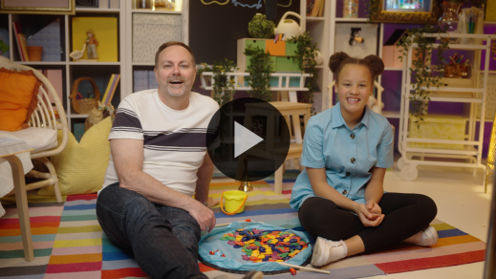

I love the story Lizzy and Grandpa shared about Jesus calling Peter to come follow Him. Peter said yes to Jesus. Lizzy said we can make a big difference when we say yes to what Jesus tells us to do. I’ve seen that truth in my life so many times.

**Response Time**

*Play a worship song quietly.*

Let’s respond to what we’ve learned today. Jesus wants us to say yes to Him. Let’s open our hands to show we’re open to whatever Jesus wants to tell us.

• *Have the kids repeat phrases of the prayer after you.*

|  |
| --- |
| *Dear Jesus, thank You for inviting me to make a difference in people’s lives. You care so much about people. You want all of us to feel Your love and know Your truth. I want to say yes to You in the small things and the big things so that I can make a difference. Amen.* |

**Faith Verse**

God loves it when we learn Bible verses from His Word. Let’s learn a new Faith Verse and put some actions to it.

[John 20:21](https://ref.ly/logosref/Bible.Jn20.21) (NLT)

[Jesus] said, ”Peace be with you. As the Father has sent me, so I am sending you.”

• *Show the* ***Faith Verse Video.***

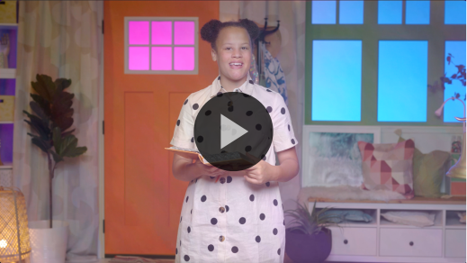

**John** *(hands at waist, spread apart, palms up and out)*

**20:** *(hands together like a clap)*

**21** *(hands opened to “book”)*

**[Jesus] said**, *(sign language for Jesus—middle finger touches center of opposite hand palm)*

**“Peace be with you.** *(wrap arms around each other like giving yourself a hug)*

**As the Father has sent me**, *(point up both index fingers for Father)*

**so I am sending you.”** *(sign language for Jesus—middle finger touches center of opposite hand palm then both index fingers point away from body)*

That was great! We’ll work on this verse again later.

**Closing**

Did you enjoy exploring God’s Word with me today? *(Group response)* We’ve worshipped God by singing. We’ve talked to Him through prayer. We learned a new Faith Verse from the Bible. We also heard that Peter chose to leave things behind and follow Jesus. We discovered that even today we can make a difference in someone’s life by saying yes to Jesus like Peter did.

• *Play the* ***Faith Fact Sound*** *video (bell ringing).*

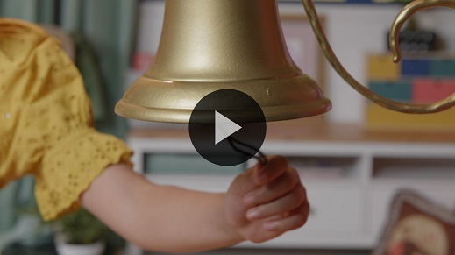

That sound means we have time to practice our Faith Fact one more time. **I can make a difference.**

• *Show the* ***Faith Fact Slide.***



Shout it with me. Ready? **I can make a difference.** Now let’s pretend we’re fishing like Peter and you can put your net in the water. *(Demonstrate the action.)* Oh, no! It’s overflowing with fish! It’s so heavy! *(Demonstrate the action.)* Let’s say our Faith Fact, knowing that when we say yes to Jesus, we can make a difference. **I can make a difference.**

**Dismissal to Small Groups**

Are your arms tired from holding that net full of fish? *(Group response)* Me, too. I’m so glad it’s time to have fun in our small groups.

• *Dismiss the kids by groups.*

|  |
| --- |
| ***Leader Tip:*** *This can be done by assigning color teams or by age groups. Note that some young preschoolers may not know their age. Using a colored sticker, jersey, or wristband will help separate the kids and help identify their small groups.* |

**Small Group**

**25 Minutes**

*See supplies and prep instructions at beginning of session or in each activity below.*

|  |
| --- |
| ***Leader Tip:*** *Small groups can alternate to each circle, or all groups can do each activity at the same time. If you choose to alternate, you will need at least one leader per circle.* |

**Circle 1**

**Group Connection**

**Domino Difference**

|  |
| --- |
| ***You Will Need***  *• Dominoes or Jenga® blocks*  *• Table or flat surface*  *No prep needed for this activity.* |

If you’re ready to help me do something fun, let me see you jump up and down. *(Group response)* Wow! You are super excited about what we’re about to do. *(Hold up a domino or Jenga block.)* Has anyone ever seen one of these? *(Group response)* These can be used for lots of things. People use them to play games or to build things. That’s what we’ll do today.

• *Put dominoes in the middle of the group.*

When it’s your turn, I want you to jump up, say your name, and then say our Faith Fact. **I can make a difference.** Once you’ve done that, pick up a domino and add it to our tower. Let’s see how big a difference we can make together. I’ll go first.

• *Jump up, say your name, and say the Faith Fact. Then, pick up a domino and place it on a flat surface in the middle of the group.*

• *Let everyone in the group do this.*

Great job, everyone. We worked together to make a difference and build our tower. Let’s make it even taller. This time I want you to jump up, say your name, and then share something that you’re really good at. Maybe you run really fast or jump really high. Maybe the thing that you’re really good at is you can sing or draw pictures. Maybe you’re good at making new friends. Whatever that thing is, make sure to share it with us when you say your name. Then, take another domino and make our tower taller. I’ll go first. My name is *(insert name)* and I’m really good at *(insert attribute).*

• *Instruct kids when it’s their turn to go.*

Whoa! That’s a great tower! As we stacked the dominoes, we each did our part to make a difference and make the tower bigger. Let’s say our Faith Fact one more time. **I can make a difference.**

**Circle 2**

**Activity Page Time**

**Fish Catch**

|  |
| --- |
| ***You Will Need***  *•* ***Small Group Activity Page****, one per kid*  *• Crayons or markers*  ***Getting Ready***  *• Print copies of the* ***Small Group Activity Page****, one per kid.* |

In our Bible story, we learned that Jesus wants to use us! A man named Peter followed Him. First, Jesus helped Peter to catch a lot of fish.

• *Hand out the* ***Small Group Activity Page*** *and crayons.*

In our Bible story today, Peter had to pull in the net to get the fish into the boat. On your page, you have to help these fish get into the boat. Trace the path for each of these fish so that they can all get into the boat.

• *Allow kids time to complete the activity.*

• *During the activity, interrupt and practice the Faith Fact:* **I can make a difference.**

• *Play the* ***Faith Fact Sound*** *video. Review the Faith Fact even if you can’t play the sound.*



You all did an amazing job catching these fish! In our Bible story, Jesus said He wanted Peter to fish for something else. Do you remember what it was? *(Allow responses.)* Jesus wanted to show Peter how to fish for people. Jesus knew Peter could make a difference by helping other people follow Jesus. He wants us to do that, too. That reminds me of our Faith Fact for today. Why don’t we all say it together. Ready? *(Group response)* **I can make a difference.** Great job!

**Circle 3**

**Feet-to-Floor Game Time**

**Go Fish**

|  |
| --- |
| ***You Will Need***  *• Small balls (table tennis balls, cotton balls, or wadded up paper balls), ten to twelve*  *• Bucket or container*  *• Round disposable tablecloth, blue if available*  ***Getting Ready***  *• Place the tablecloth on the floor with the bucket in the middle of the tablecloth.* |

Who likes playing games? *(Group response)* I love to play games! In today’s Bible story, we learned that Jesus got in the boat with Peter. After Jesus finished teaching the crowd of people, Jesus told Peter to go fishing. While Peter was fishing, he caught many fish. In fact, he caught so many fish that Peter had to call his friends in another boat to come help him pull the fish in. Their boats were filled up with fish. That’s a lot of fish!

In our game today, you’ll have a chance to help Peter catch these fish in our pond. *(Hold up a ball.)* You’ll work together to catch them and put them all in the bucket. *(Point to bucket.)* The good thing for us is that these fish don’t swim.

• *Instruct kids to sit around the edge of the tablecloth.*

Now, pretend that your arm and hand is a fishing pole. Like a real fishing pole, you can only catch one fish at a time. When I say, “Go,” you’ll pick up these fish and toss them in the bucket one at a time. Each time you catch a fish, you have to stand up, hop on both feet, and say our Faith Fact: **I can make a difference.** Then, you can sit down and try to get another fish. Give me two thumbs up if you’re ready to play. *(Group response)* Great! Let’s go fish!

• *Scatter the balls around on the tablecloth.*

• *Let kids play the game until all the fish are caught.*

• *Optional: Play again. Consider changing the actions for each round.*

Wow! Everyone did such a good job catching these fish. I know Peter had some great friends who helped him like you helped me. Jesus used Peter to make a difference, and He wants to use you and me to make a difference, too!

**Circle 4**

**Hands-On Learning**

**Important Delivery**

|  |
| --- |
| ***You Will Need***  *•* ***Small Group Hands-On Learning Page****, one per two kids*  *• Assorted mail (letters, large envelopes, boxes, etc.)*  *• Crayons or markers*  *• Scissors*  *• Card stock, if available*  *• Optional: World map if you have a place to display the kids’ postcards*  ***Getting Ready***  *• Print the* ***Small Group******Hands-On Learning Page*** *on card stock (if available) and cut apart, one per two kids.*  *• Optional: Write the Faith Verse on the world map.* |

*(Hold up the mail.)* Have you ever received a letter or package in the mail? *(Group response)* What are some reasons why you might get mail like this? *(Allow responses.)* I don’t know what was inside the mail you got, but one thing I know for sure is what was on the outside. In order for you to get a letter or package, someone had to send it to you. They had to make sure your name was on it.

Even more important than your name was something else written on it. Do you have a guess what that might be? *(Allow responses.)* Yes! It needs your address. Once the package has your address on it, there’s only one other thing that’s missing. Do you know what it is? *(Allow responses.)* Right! It needs a stamp. Can you find the stamps or postage mark on this mail?

• *Let kids point out the stamps or postage mark on the mail.*

All this talk about sending things reminds me of our Faith Verse. Why don’t we take a minute and practice our Faith Verse?

[John 20:21](https://ref.ly/logosref/Bible.Jn20.21) (NLT)

[Jesus] said, ”Peace be with you. As the Father has sent me, so I am sending you.”

• *Show the* ***Faith Verse Video.***



**John** *(hands at waist, spread apart, palms up and out)*

**20:** *(hands together like a clap)*

**21** *(hands opened to “book”)*

**[Jesus] said**, *(sign language for Jesus—middle finger touches center of opposite hand palm)*

**“Peace be with you.** *(wrap arms around each other like giving yourself a hug)*

**As the Father has sent me**, *(point up both index fingers for Father)*

**so I am sending you.”** *(sign language for Jesus—middle finger touches center of opposite hand palm then both index fingers point away from body)*

In our verse Jesus isn’t talking about sending a letter or package like this mail we have. What does Jesus want to send? *(Allow responses.)* Right! Jesus said He wants to send you and me. Where do you think He’s going to send us? *(Allow responses.)* Those are some great places you listed.

• *Hand out crayons and the postcards from the* ***Hands-On Learning Page****.*

Who is this postcard addressed to? *(Allow responses.)* It says, “The World.” That’s exactly where Jesus is sending us. He’s sending us to the world to make a difference. Jesus wants you to let people in your world know about Him. So draw a picture of yourself in the message part of your postcard. Show Jesus that He can send you to make a difference and tell others about His love.

• *Give kids time to complete the postcards.*

• *Optional: If you have a bulletin board or clothesline to display kids’ work, consider displaying these postcards and a map of the world with the Faith Verse written on it.*

I’m so glad that Jesus chose people like you and me to send to the world so that we can make a difference.

**Dismissal**

• *Play the* ***Faith Fact Sound*** *video (bell ringing).*



• *Show the* ***Faith Fact Slide.***



Today has been amazing! I loved getting to play, praise, and pray with you as we learned more about Jesus. I have an idea! Before our time is over, let’s say the Faith Fact together one more time! When I say, “Go!” I want you to say it as quietly as you can. Ready? Go! **I can make a difference.** Now, shout it. Go! **I can make a difference.** That was so great! I can’t wait to learn more about Jesus next time with you!

• *Send home the* ***Small Group Activity Page*** *and the postcard from the* ***Hands-On Learning Page*** *with each kid.*

• *Remind parents that there are* ***Family Devotions*** *available on the app to do with their kid.*

• *Tell everyone the date and time for the next session.*